**Task 3: Round Robin**

Time Quantum = 4 ms

Check for incoming processes after every time quantum (4 ms).

**Sample input:**

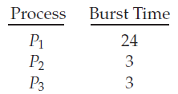

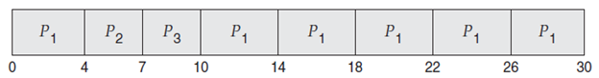

N.B.

Input for each task will be :

* Number of processes
* Arrival time of each process. If all processes arrive at the same time, this can be set to 0 for all processes.
* Burst time of each process
* Priority of each process (If required)

Output will be:

* Completion Time(CT), Turnaround Time(TAT), Waiting Time(WT)
* Average turnaround Time, average waiting time